1. Firstly, Apply your local PC admin access:

<http://aws.ap.autoliv.int/index.jsp>

* IT/ Local Admin request.

1. Copy all “Tool” folder into your local PC, and start to install related SW .
2. Reading study material from “ MVSG Platform SX11__Ray Confirmed Aug20 2018 ”.

IT request for other engineering tools:

IT Request linkage is:

<https://veoneer.service-now.com/sp?id=sc_category&sys_id=2809952237b1300054b6a3549dbe5dd4>

* Doors Access:

Doors is a requirement management tool.

* First, you need to request Citrix access by ‘IT Request -> User Access Request’, then fill in the blanks as the graphic below.

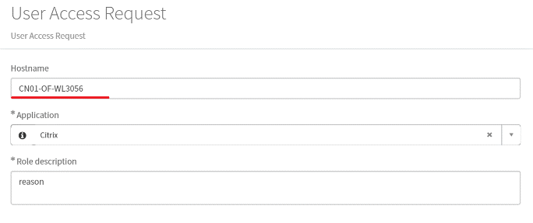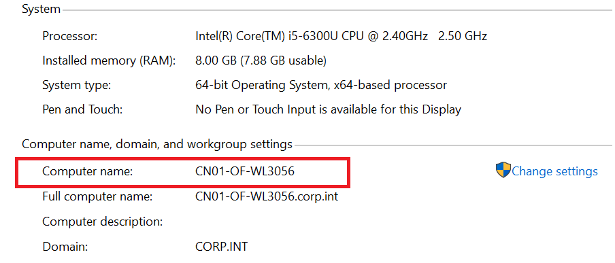

* Fill in ‘Hostname’ using strings on the right, select Citrix in ‘Application’, then enter your reason.
* Second, you need to request Doors access by ‘IT Request -> Doors’
* PTC Access:

PTC is used for product management. You can request by ‘IT Request -> PTC’

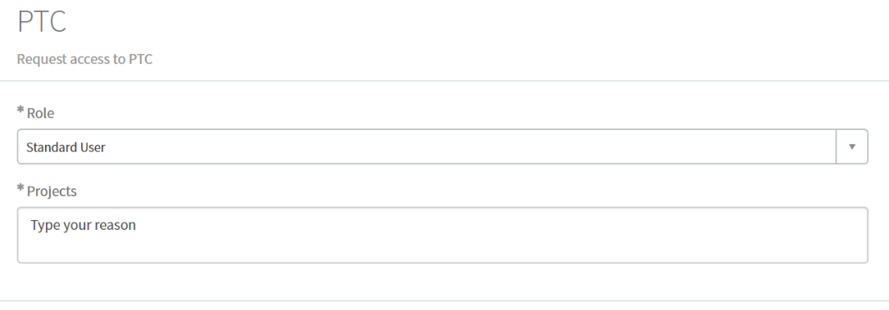

* PLM Access:

PLM is product lifetime management tool for Autoliv, you can request by ‘IT Request -> PLM’

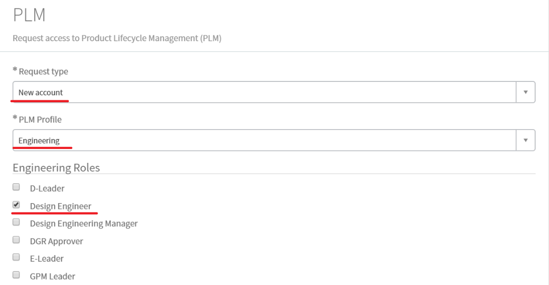

* Enterprise Architect

Enterprise Architect is a tool for designing system architecture. You can request by ‘IT Request -> User Access Request’.

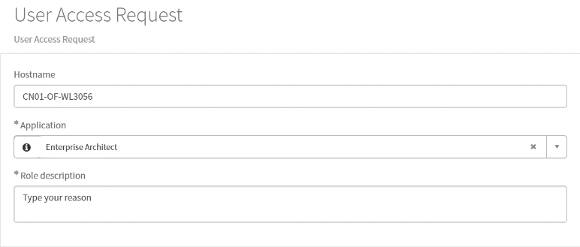

* 7Zip

You can request by ‘IT Request -> User Access Request’

* AFIS

AFIS is used for recording your work effort. You can request by ‘IT -> User Access Request’

Website Access:

* Jira

This is a website where different projects are managed, and project relevant tasks are assigned to different person, you can enter by your windows name and password.

* SharePoint

Different projects have different SharePoint locations, where project related information is stored. You can request for SharePoint access when you need.

Geely SX11 SharePoint:

<https://veoneer.sharepoint.com/sites/MVS3GGeelySX11New/_layouts/15/AccessDenied.aspx?Source=https%3a%2f%2fveoneer.sharepoint.com%2fsites%2fMVS3GGeelySX11New%2fSitePages%2fHome.aspx&correlation=b7c5909e-90b7-6000-a527-a10383b06f7d&Type=item&name=bd251417-72da-44ef-baaa-28985f4d6ea8&listItemId=1>

* Active Directory

You need to consult HR for this account, before you can request for an AWS access.

* AWS Access

You should use your Active Directory to enter AWS ( <http://aws.ap.autoliv.int/index.jsp> ). However, you have to get a AWS access first, or you will get a warning below.

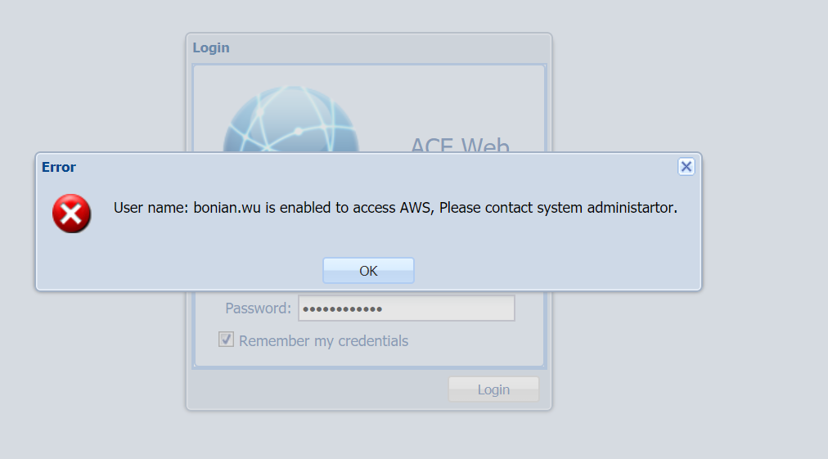

You can request for AWS access by ‘IT Request -> Generic Request’, then type what you want.

